1. To make my PizzaApp easier to understand, I use put different toppings in groups. Also, I will put checkbox in one group, radiobox in one group.
2. I create a class which sets a unit price of meats, and another class sets unit price of veggies.
3. I can create a structure that includes price and name of the topping. This type of data structure can be changed easily when we want to make any changes of this program.
4. For MVC, I will collect some same or similar methods in one class or one data structure. For example, in this assignment, I may use a class called veggiesUnitPrice, so if I want to change the unit price, I just make changes in this class.
5. 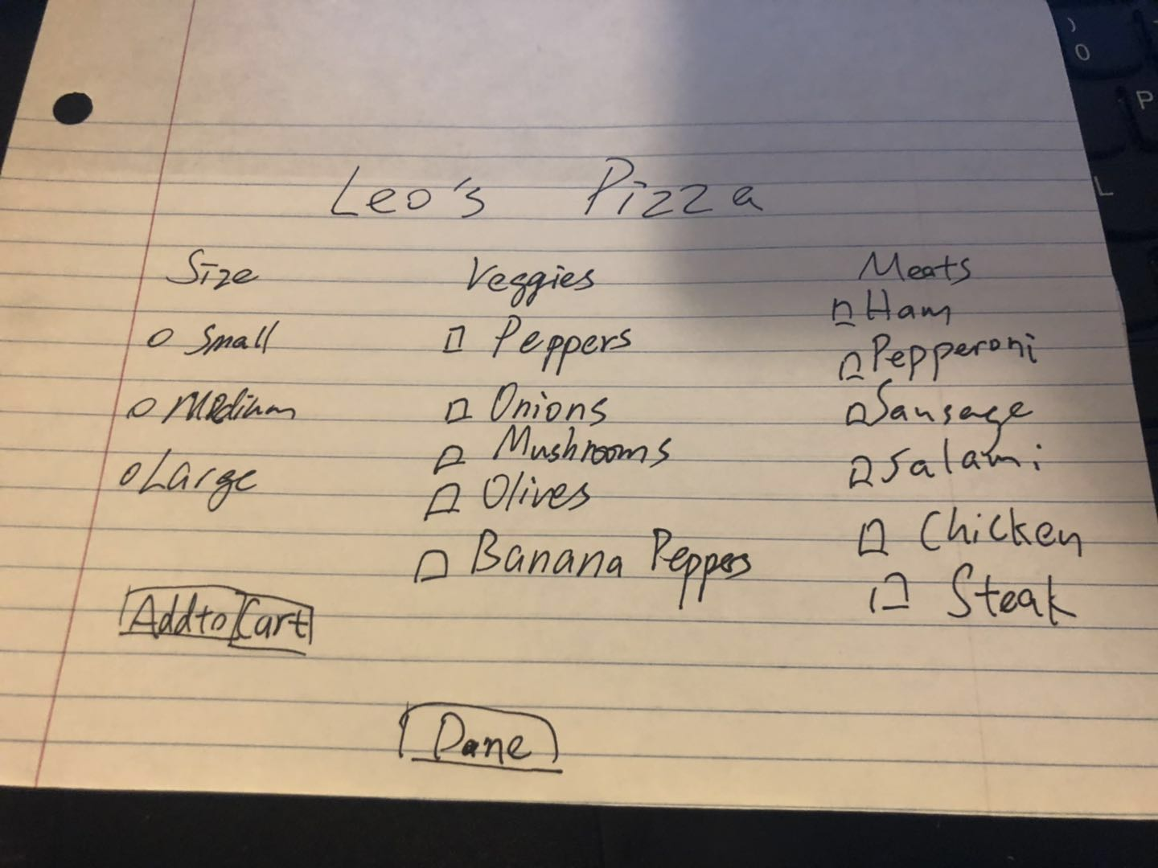

The picture above is my sketch for this assignment. I am trying to group all same feature in one group.